Fundamental Concepts of Spatial Data Representation in Geographic Information Systems (GIS)

1. Introduction
Geographic Information Systems (GIS) are used to capture, store, analyze, and visualize real-world spatial data. To represent the real world inside a computer, GIS uses different conceptual views, transformation processes, and data models.
Understanding how spatial data is represented is essential for correct mapping, analysis, and decision-making.
SPACIAL DATA REPRESENTATION:

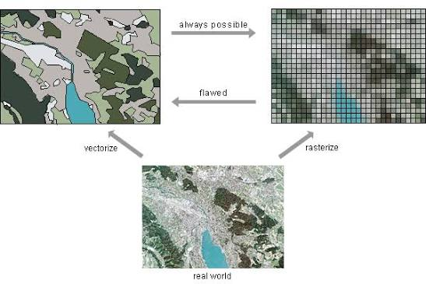

2. User View Models in GIS
User View Models describe how people mentally understand and visualize geographic space. There are two major views:

Object-Based View (Discrete Model)

Concept
The real world is seen as objects with clear boundaries.
Examples: buildings, roads, trees, lakes, land parcels.

Characteristics
- Objects exist as independent units
- Each object has specific attributes (e.g., name, height, type)
- Used when features have clear shapes or boundaries

Example
- A road network map
- A map showing hospitals, schools, and bus stops

Field-Based View (Continuous Model)

Concept
The world is seen as continuous surfaces where every location has a value.
Examples: temperature everywhere, rainfall, elevation.

Characteristics
- No fixed boundaries
- Values change smoothly across space
- Used for environmental and natural phenomena

Example
- Temperature map of Pakistan
- Rainfall distribution map
- Elevation (DEM) maps

Difference Summary
Feature | Object-Based | Field-Based
Represents | Discrete objects | Continuous surfaces
Example | Roads, buildings | Rainfall, temperature
Boundary | Clear | No clear boundaries
Data Type | Vector | Raster

3. Data Transformation Processes
Real-world data is often incomplete, sampled, or raw. GIS uses data transformation to convert observations into useful spatial information.

Interpolation / Gridding

Concept
Interpolation predicts values at locations where no measurement exists.

Purpose
- Converts scattered data points into a continuous surface
- Used in weather maps, soil moisture data, etc.

Example
- Weather stations report temperature at only 30 locations → GIS uses interpolation to create a complete temperature map.

Approximation

Concept
Simplifies complex shapes or lines while keeping the general structure.

Purpose
- Reduces data size
- Makes maps faster and easier to process

Example
- Smoothening a coastline
- Simplifying boundaries of a city
- Reducing too many vertices in a road line

Object Recognition

Concept
GIS identifies objects from raw data such as satellite images or LiDAR point clouds.

Purpose
- Convert unstructured data into meaningful objects

Examples
- Recognizing buildings from satellite images
- Detecting road networks automatically
- Extracting tree canopy from aerial photos

4. GIS Data Models
Spatial data inside GIS is stored using two main data models: Vector and Raster.
Both represent space but in different ways.

Vector Data Model

Concept
Stores geographic features as points, lines, and polygons.

Examples
- Points: ATM locations, bus stops
- Lines: roads, rivers, pipelines
- Polygons: city boundaries, land parcels, lakes

Advantages
- High precision
- Good for representing objects with boundaries
- Efficient for network analysis (roads, utilities)
- Smaller file size compared to raster

Suitable For
- Urban planning
- Land administration
- Road networks
- Utility mapping

Raster Data Model

Concept
Represents space as a grid of cells/pixels, each with a value.

Examples
- Satellite images
- Elevation models (DEM)
- Land cover maps
- Temperature or rainfall maps

Advantages
- Best for continuous data
- Simple structure (matrix/grid)
- Ideal for image processing and surface analysis
- Enables advanced modeling (slope, distance, hydrology)

Suitable For
- Remote sensing
- Environmental modeling
- Terrain analysis
- Weather forecasting

Difference Summary
Feature | Vector | Raster
Structure | Points, lines, polygons | Grid cells/pixels
Best For | Discrete objects | Continuous data
File Size | Smaller | Larger (depends on resolution)
Accuracy | Very high | Depends on cell size
Examples | Roads, boundaries | Temperature, elevation, images

RASTERS VS VECTOR

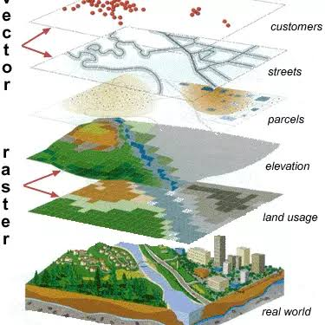

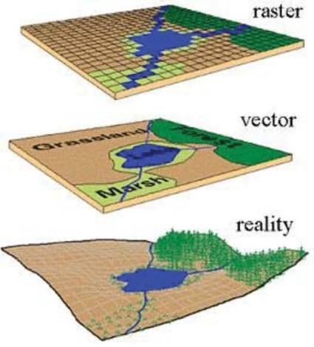

5. Conclusion
Spatial data representation in GIS is the foundation of all geographic analysis.
Understanding User View Models (object vs. field), Data Transformations (interpolation, approximation, object recognition), and Data Models (vector vs. raster) allows GIS professionals to choose the correct method for mapping and decision-making.
Choosing the right model depends on the type of real-world phenomenon and the purpose of analysis.

